## Q 5.3 Making a moving sinusoidal grating with a color map

A moving sinusoidal grating is one of the classic stimuli of vision research. Just as a pure tone is a fundamental auditory stimulus, a moving grating is a fundamental stimulus for visual motion. This problem works through one way of making a moving grating.

a) Make a simple grayscale ramp by using *image* on a matrix M=1:256 and colormap(gray(256)). It should look like this:

b) Make a new color map of size 256x3 with each of the three columns (r, g and b) modulating sinusoidally from 0 to 1 for four cycles with a phase of pi. (If you’re rusty on your trigonometry, see the Hints section). A plot of each column of the color map should look like this:



50

100

150

200

250

0.5

1

1.5

Apply this color map to the ramp image. You should get this: A sinusoidal grating! Think about why this happens using the ‘paint pots’ analogy.

c) Make the grating move or ‘drift’ rightward by changing the phase in a loop, resetting the color map and using the ‘drawnow’ command. You can make the grating drift through 4 cycles over 100 frames by setting the phase with a loop like this:

for phase = linspace(0,8*pi,100)

.

.

.

end

## Q 5.3 Magic Letters

Starting with these two matrices:

Z=[ 1 1 1 1 1; ...

0 0 0 0 1; ...

0 0 0 1 0; ...

0 0 1 0 0; ...

0 1 0 0 0; ...

1 0 0 0 0; ...

1 1 1 1 1];

T=[ 1 1 1 1 1; ...

0 0 1 0 0; ...

0 0 1 0 0; ...

0 0 1 0 0; ...

0 0 1 0 0; ...

0 0 1 0 0; ...

0 0 1 0 0];

Combine Z and T to create a matrix ZT and create two colormaps (which will need to have 4 rows): cmapZ and cmapT, such that the following commands create the following two images.

image(ZT); axis off

colormap(cmapZ);

colormap(cmapT)

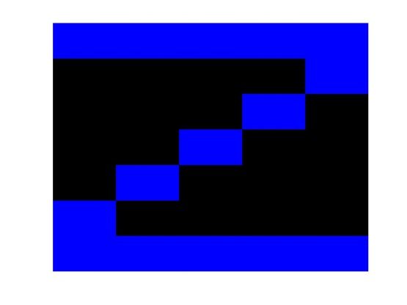

## Q 5.4 Altering the tightrope random walk model

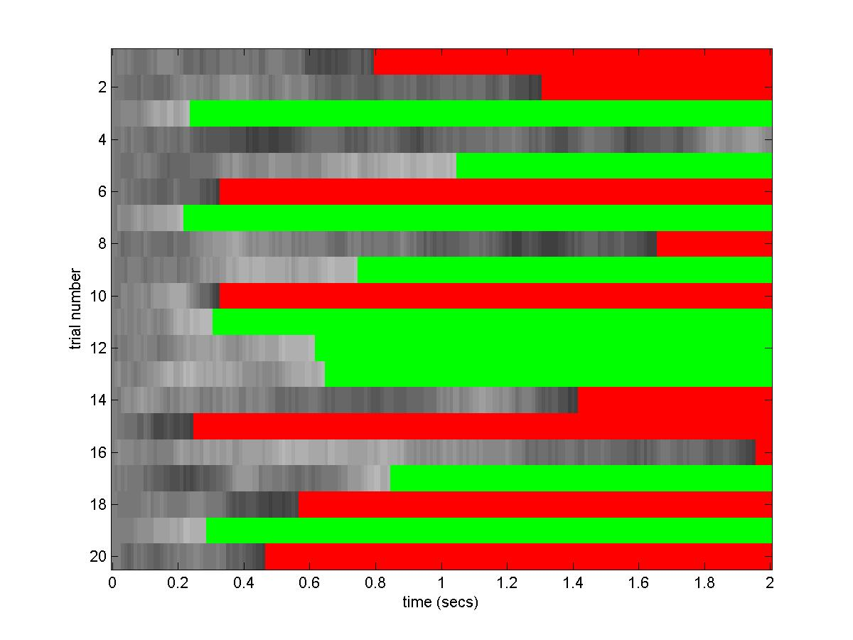

Q